Flowchart 3, Week 2, Lab 4
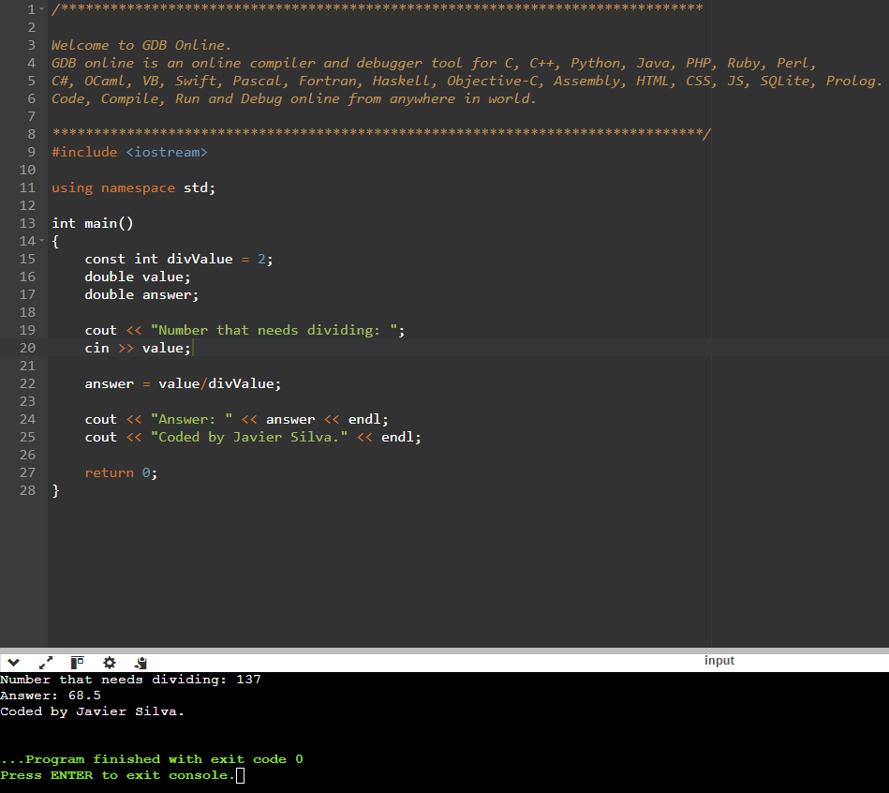

Flowchart 3, Week 2, Lab 6
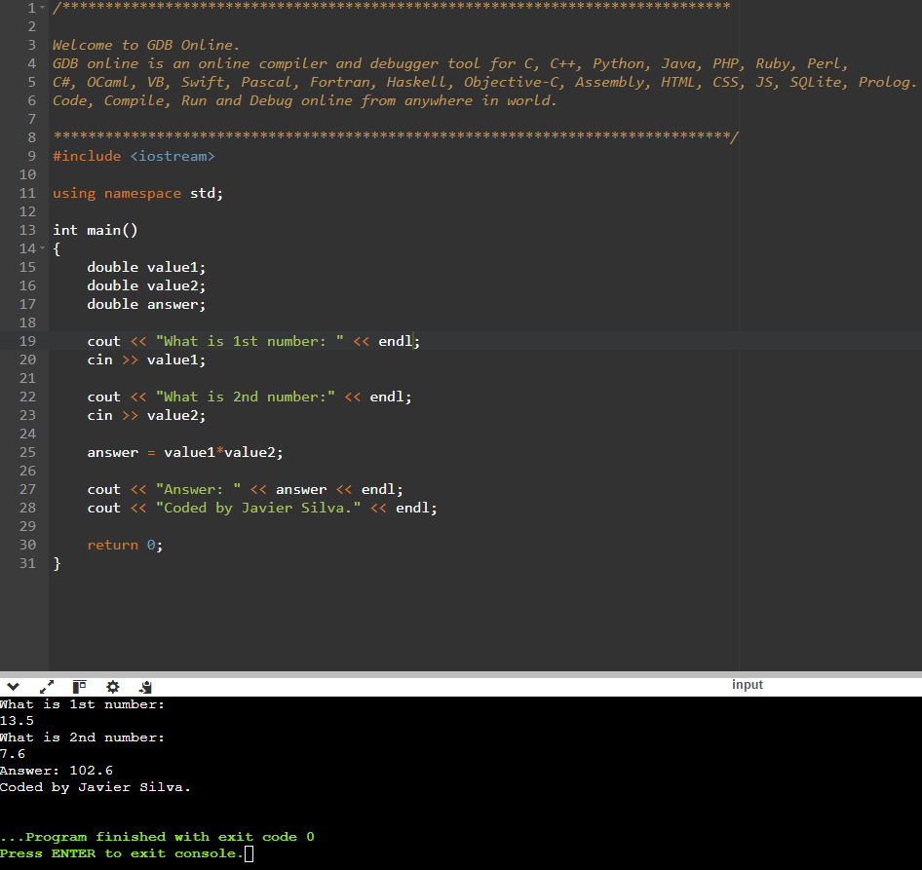

Flowchart 3, Week 2, Lab 7a
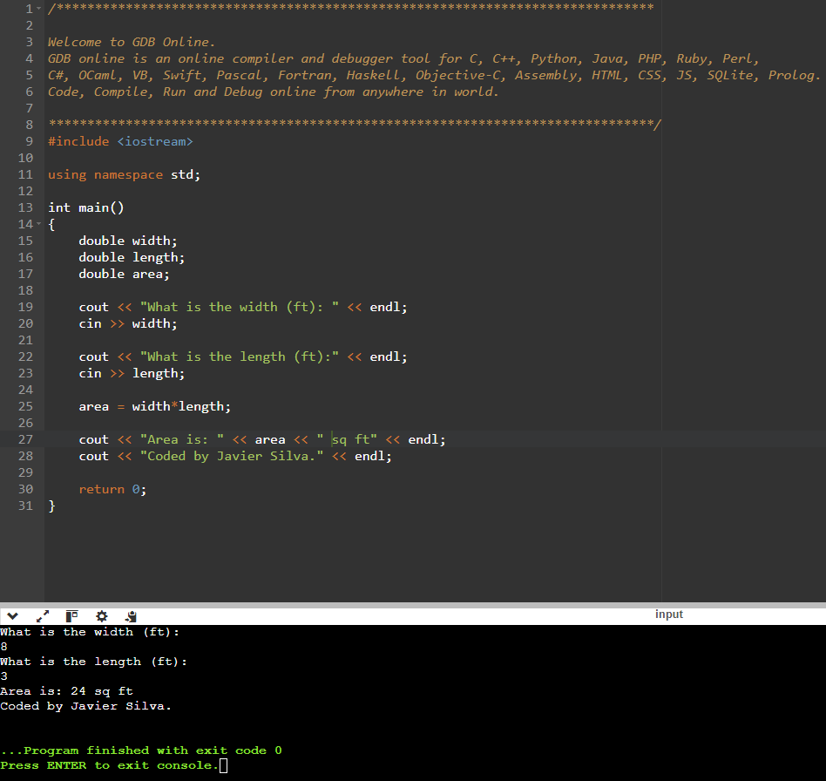

Flowchart 3, Week 2, Lab 9
